Tommy Thongsythavong

CSC 520

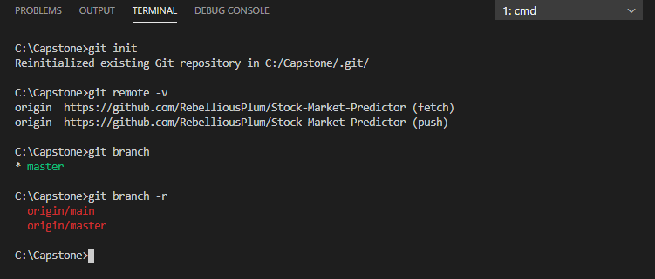

You have been invited already to be a collaborator on the repository through github.

Link to repository:

<https://github.com/RebelliousPlum/Stock-Market-Predictor>

It is set to private.